16  Pancakes w/ Syrup  Or Cereal Choice  Apple and Fruit Juice  1% White or Skim Milk | 17  Mini Cini  Or Cereal Choice  Apple and Fruit Juice  1% White or Skim Milk | 18  Cream Cheese Bagel  Or Cereal Choice  Apple and Fruit Juice  1% White or Skim Milk | 19  Breakfast Pizza  Or Cereal Choice  Apple and Fruit Juice  1% White or Skim Milk | 20  WG Donuts  Or Cereal Choice  Apple and Fruit Juice  1% White or Skim Milk
23  Pancakes w/ Syrup  Or Cereal Choice  Apple and Fruit Juice  1% White or Skim Milk | 24  Breakfast Wrap  Or Cereal Choice  Apple and Fruit Juice  1% White or Skim  Milk | 25  Cream Cheese Bagel  Or Cereal Choice  Apple and Fruit Juice  1% White or Skim Milk | 26  Blueberry Waffle  Or Cereal Choice  Apple and Fruit Juice  1% White or Skim Milk | 27  WG Donuts  Or Cereal Choice  Apple and Fruit Juice  1% White or Skim Milk
2  Pancakes w/ Syrup  Or Cereal Choice  Apple and Fruit Juice  1% White or Skim Milk | 3  Mini Cini  Or Cereal Choice  Apple and Fruit Juice  1% White or Skim Milk | 4  Cream Cheese Bagel  Or Cereal Choice  Apple and Fruit Juice  1% White or Skim Milk | 5  Breakfast Pizza  Or Cereal Choice  Apple and Fruit Juice  1% White or Skim Milk | 6  WG Donuts  Or Cereal Choice  Apple and Fruit Juice  1% White or Skim Milk
9  Pancakes w/ Syrup  Or Cereal Choice  Apple and Fruit Juice  1% White or Skim Milk | 10  Breakfast Wrap  Or Cereal Choice  Apple and Fruit Juice  1% White or Skim  Milk | 11  Cream Cheese Bagel  Or Cereal Choice  Apple and Fruit Juice  1% White or Skim Milk | 12  Blueberry Waffle  Or Cereal Choice  Apple and Fruit Juice  1% White or Skim Milk | 13  WG Donuts  Or Cereal Choice  Apple and Fruit Juice  1% White or Skim Milk
Monday | Tuesday | Wednesday | Thursday | Friday


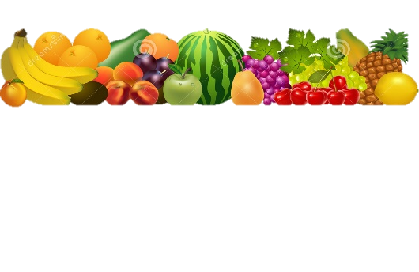


MHY Family Services

Feb/March Breakfast

What is a Meal?
You must choose at least 3 of the 5 components available for the school lunch price.
Minimum of ½ cup serving of fruit or a minimum of a ½ cup of vegetable must accompany a reimbursable lunch
Meat or Meat Alternate
Choice of Vegetable
Choice of Fruit
Grain/Bread
Choice of Fruit
Grain/Bread
Choice of Milk- 1% White or Fat-Free Chocolate

Weekly Vegetable Subgroups May Include:
Dark green - spinach, broccoli, romaine and spring salad
Red/Orange - carrots, sweet potatoes, tomatoes, red peppers
Beans/Peas
Starchy - white potatoes, corn,
and lima beans
Other Vegetables: celery sticks, cucumbers, cauliflower, green peppers,
green beans and cabbage

Daily Fruit Selection May Include:
oranges, apples, bananas, grapes, pears, peaches, cantaloupe, melon, strawberries, applesauce, pineapple, mandarin oranges, and 100% fruit juices
LEAVE YOUR LUNCHBOX AT HOME!
DAILY ALTERNATES.

Daily entrée options may include:
Sunbutter and Jelly on whole grain Sliced Bread, Gluten free alternative

Nutritious Friends
Look for our Nutritious Friend of the Month on the menu!!
Lunch Prices
Student $0.00
Adult $0.00
General Manager
Lynn Paga 724-602-8168
Email
ma1066@metzcorp.com
USDA is an equal opportunity provider and employer

