

MHY Family Services

May 2026 Breakfast

11  Breakfast on a stick  w/ Syrup or Cereal  Apple and Fruit Juice  Lowfat Chocolate  Strawberry or  1% White Milk | 12  Mini Cini  Or Cereal Choice  Apple and Fruit Juice  Lowfat Chocolate  Strawberry or  1% White Milk | 13  Cream Cheese Bagel  Or Cereal Choice  Apple and Fruit Juice  Lowfat Chocolate  Strawberry or  1% White Milk | 14  Breakfast Pizza  Or Cereal Choice  Apple and Fruit Juice  Lowfat Chocolate  Strawberry or  1% White milk | 15  WG Donuts  Or Cereal Choice  Apple and Fruit Juice  Lowfat Chocolate  Strawberry or  1% White Milk
18  Breakfast on a Stick  w/ Syrup or Cereal  Apple and Fruit Juice  Lowfat Chocolate  Strawberry or  1% White Milk | 19  Apple Strudel  Or Cereal Choice  Apple and Fruit Juice  Lowfat Chocolate  Strawberry or  1% White Milk | 20  Cream Cheese Bagel  Or Cereal Choice  Apple and Fruit Juice  Lowfat Chocolate  Strawberry or  1% White Milk | 21  Blueberry Waffle  Or Cereal Choice  Apple and Fruit Juice  Lowfat Chocolate  Strawberry or  1% White Milk | 22  WG Donuts  Or Cereal Choice  Apple and Fruit Juice  Lowfat Chocolate  Strawberry or  1% White Milk
25  Happy Memorial  Day!!! | 26  Mini Cini or  Cereal Choice  Apple and Fruit Juice  Lowfat Chocolate  Strawberry or  1% White Milk | 27  Cream Cheese Bagel  Or Cereal Choice  Apple and Fruit Juice  Lowfat Chocolate  Strawberry or  1% White Milk | 28  WG Donuts  Or Cereal Choice  Apple and Fruit Juice  Lowfat Chocolate  Strawberry or  1% White Milk | 29  Have a Great  Summer!


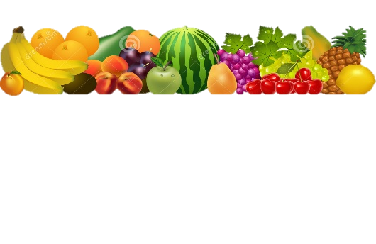
What is a Meal?
You must choose at least 3 of the 5 components available for the school lunch price.
Minimum of ½ cup serving of fruit or a minimum of a ½ cup of vegetable must accompany a reimbursable lunch
Meat or Meat Alternate
Choice of Vegetable
Choice of Fruit
Grain/Bread
Choice of Fruit
Grain/Bread
Choice of Milk- 1% White or Fat-Free Chocolate

Weekly Vegetable Subgroups May Include:
Dark green - spinach, broccoli, romaine and spring salad
Red/Orange - carrots, sweet potatoes, tomatoes, red peppers
Beans/Peas
Starchy - white potatoes, corn,
and lima beans
Other Vegetables: celery sticks, cucumbers, cauliflower, green peppers,
green beans and cabbage

Daily Fruit Selection May Include:
oranges, apples, bananas, grapes, pears, peaches, cantaloupe, melon, strawberries, applesauce, pineapple, mandarin oranges, and 100% fruit juices
LEAVE YOUR LUNCHBOX AT HOME!
DAILY ALTERNATES.

Daily entrée options may include:
Sunbutter and Jelly on whole grain Sliced Bread, Gluten free alternative

Nutritious Friends
Look for our Nutritious Friend of the Month on the menu!!
Lunch Prices
Student $0.00
Adult $0.00
General Manager
Lynn Paga 724-602-8168
Email
ma1066@metzcorp.com
USDA is an equal opportunity provider and employer

